Calibration of X and Y axis for centre of rotary bed for 5-axis Voron Trident 3D printer modification

This is a guide with a g-code programme to calibrate the exact centre of the rotary bed for 5-axis 3D printers.

After assembling your printer and calibrating the Z axis to the correct print for print (Z=0.2mm) height and extruder calibration steps for the correct extrusion length.

Firstly, please print out the calibration g-code programme for your 5-axis 3D printer.

The program is designed to show any difference if the nozzle is not in the exact centre of the bed.

The printer must be set up in the exact centre of the rotary bed in order to use the 5-axis kinetics and to print the full 5-axis simultaneously.

In the first part of g-code program will print calibration strips exactly as show on the Figure 1a

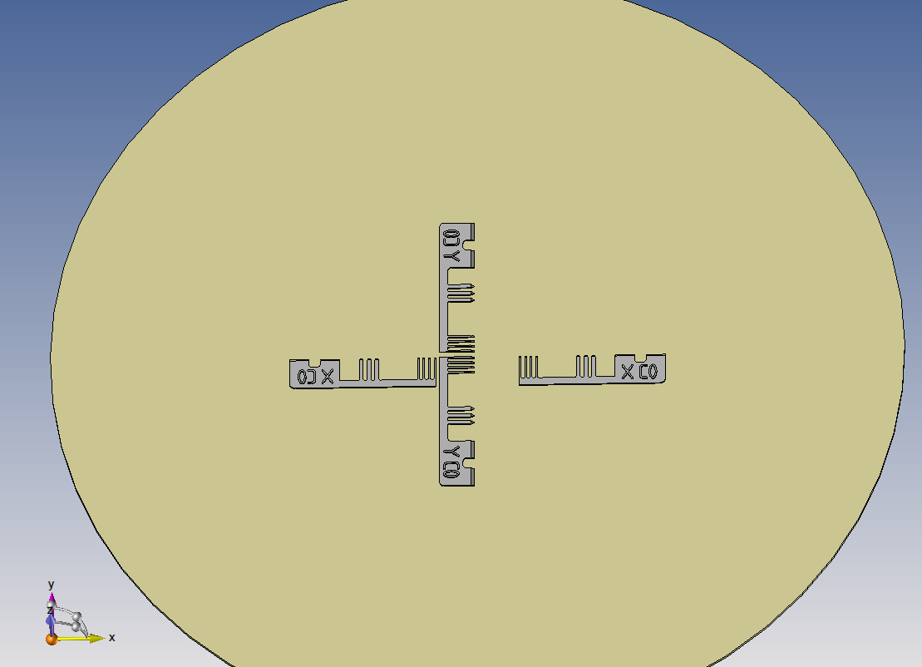

*Figure 1a*

The second part of the G-code programme will print exactly the same calibration strips, but after rotating the C-axis 180 degrees, so that when the print is complete and the nozzle is calibrated to the exact centre of the rotary bed, the full print should look like *Figure 1b*.

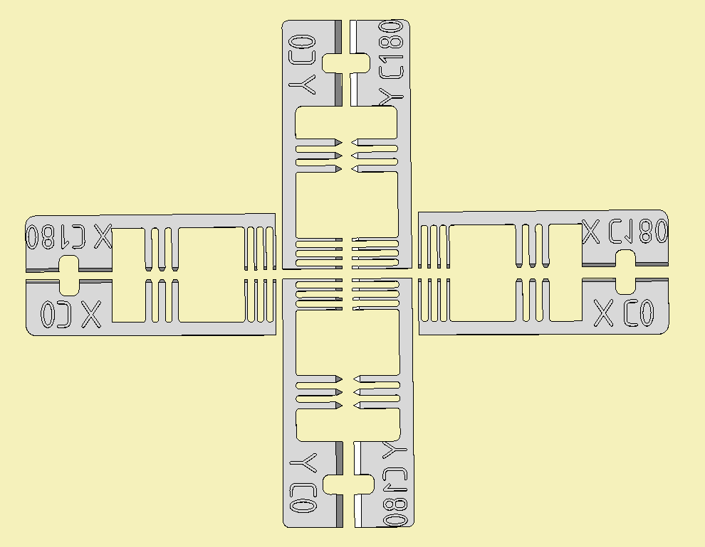

*Figure 1b*

As you can see, the calibration strips are aligned and there is no difference between the first printed

Calibration strip X C0 and the second printed calibration strip X C180 and the second printed calibration strip

Y C0 and calibration strip Y C180. This means that the nozzle is exactly in the centre of the rotary bed.

If the final print looks like Figure 2a, then the nozzle is not in the centre and adjustment is required to move the nozzle to the centre.

The adjustment is made in the printer settings in homex.g for the X axis and homey.g for the Y axis.

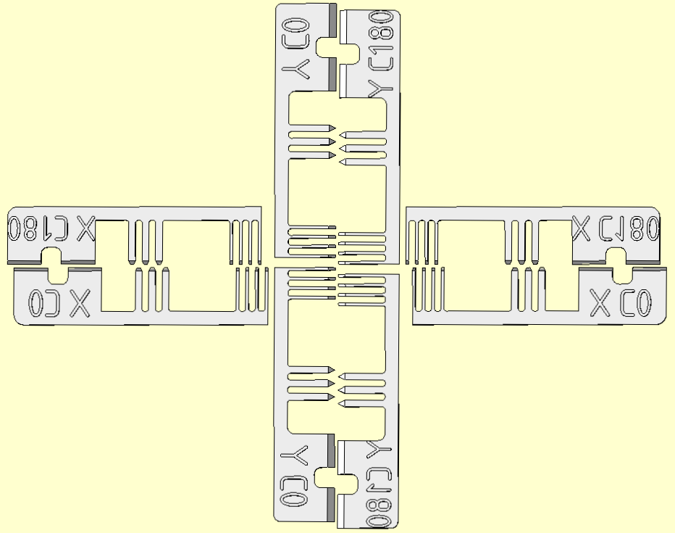  
*Figure 2a*

Measure the distance between the calibration strips for X and Y as shown on *Figure 2b*

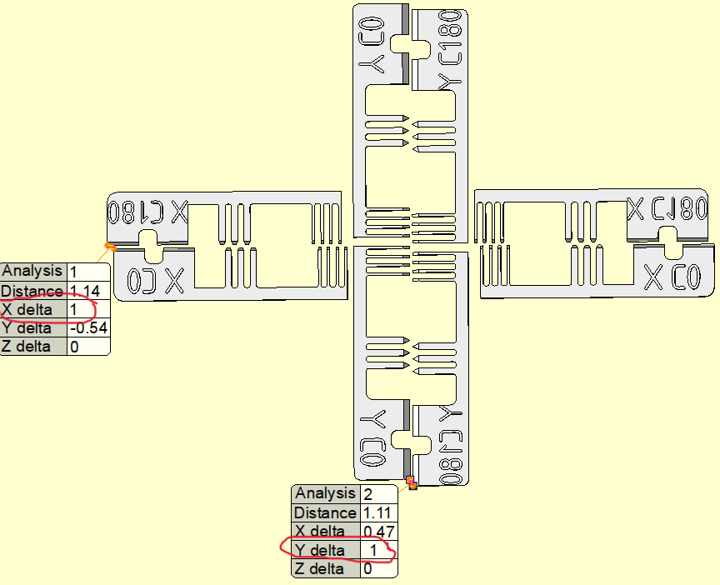

*Figure 2b*

As shown in Figure 2b, the distance of the X axis is 1mm (X delta) and the distance of the Y axis is also

1mm (Y delta).

In this case we need to adjust the parameters. First the X axis.

In a DuetWeb interface from the printer, go to System and open the homex.g file.

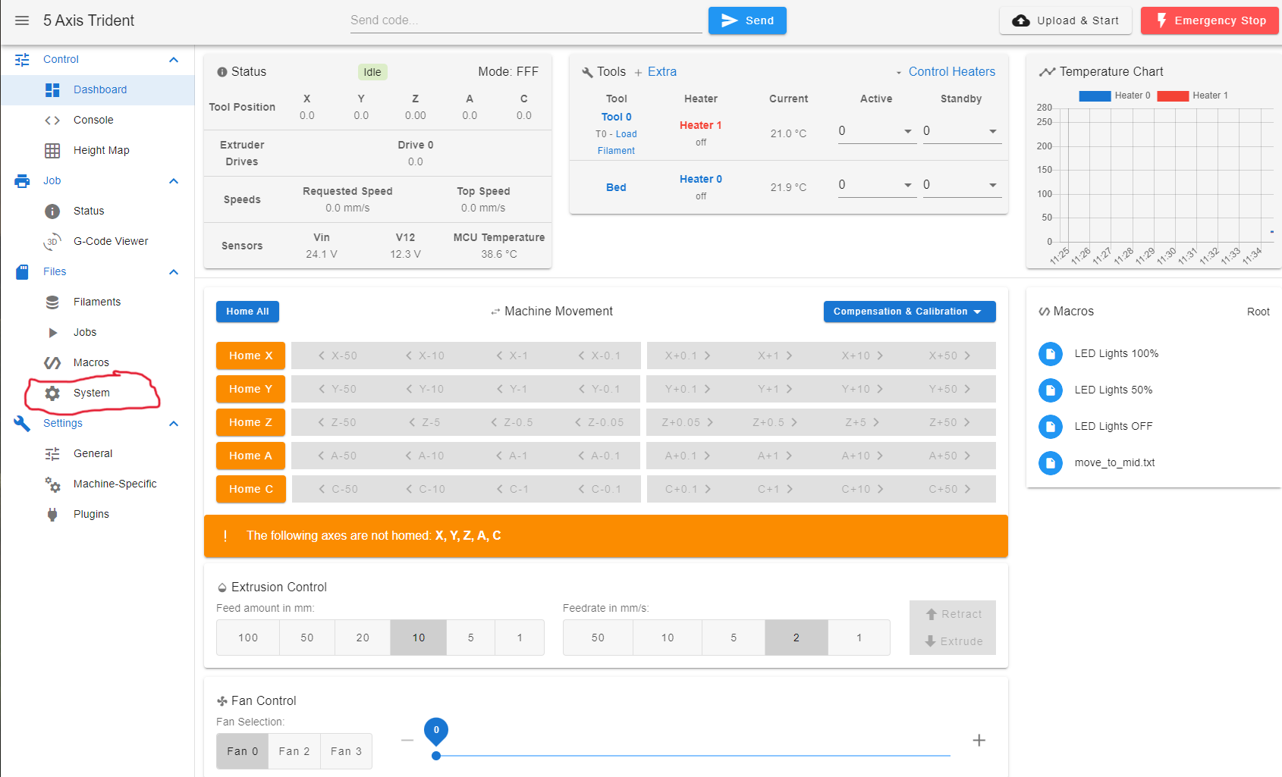

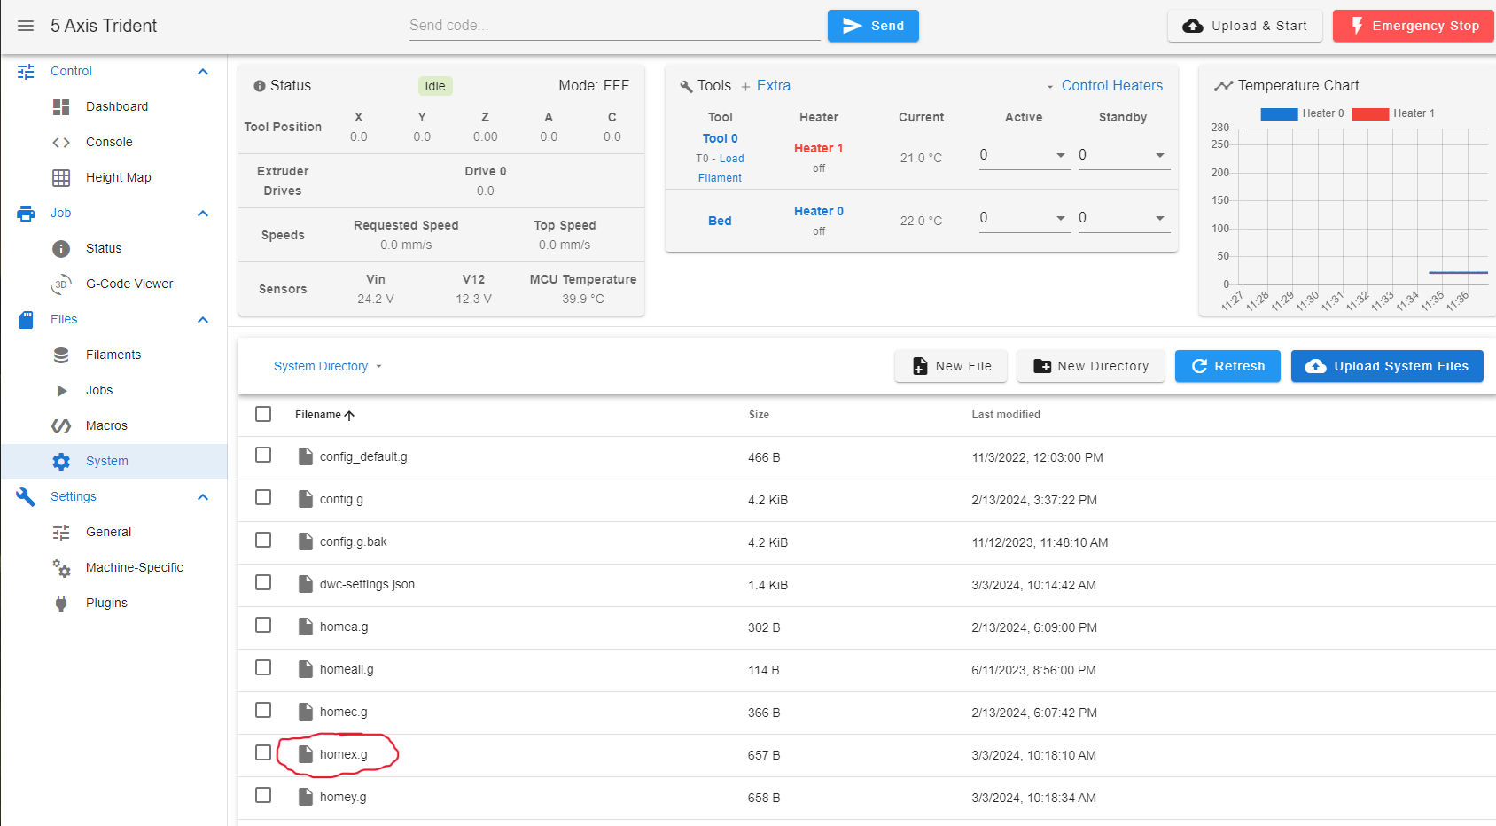

In the file, adjust the length of the X axis in line 11 (in this example X120.94 mm), after correction the value will be X121.44 mm, exactly half the measurement from our print where the distance was 1mm.

So in this case plus 0.5mm

**Note:**

**If the second calibration strip X C180 is printed a little more to the left of the first calibration strip X C0, the value will go to the plus.**

**If the calibration strip X C180 is printed more to the right, the changed value will go to the minus.**

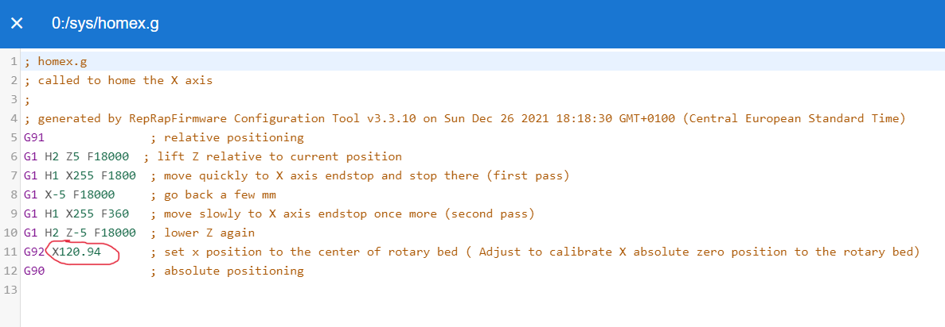

Now the same with Y axis

Please open file homey.g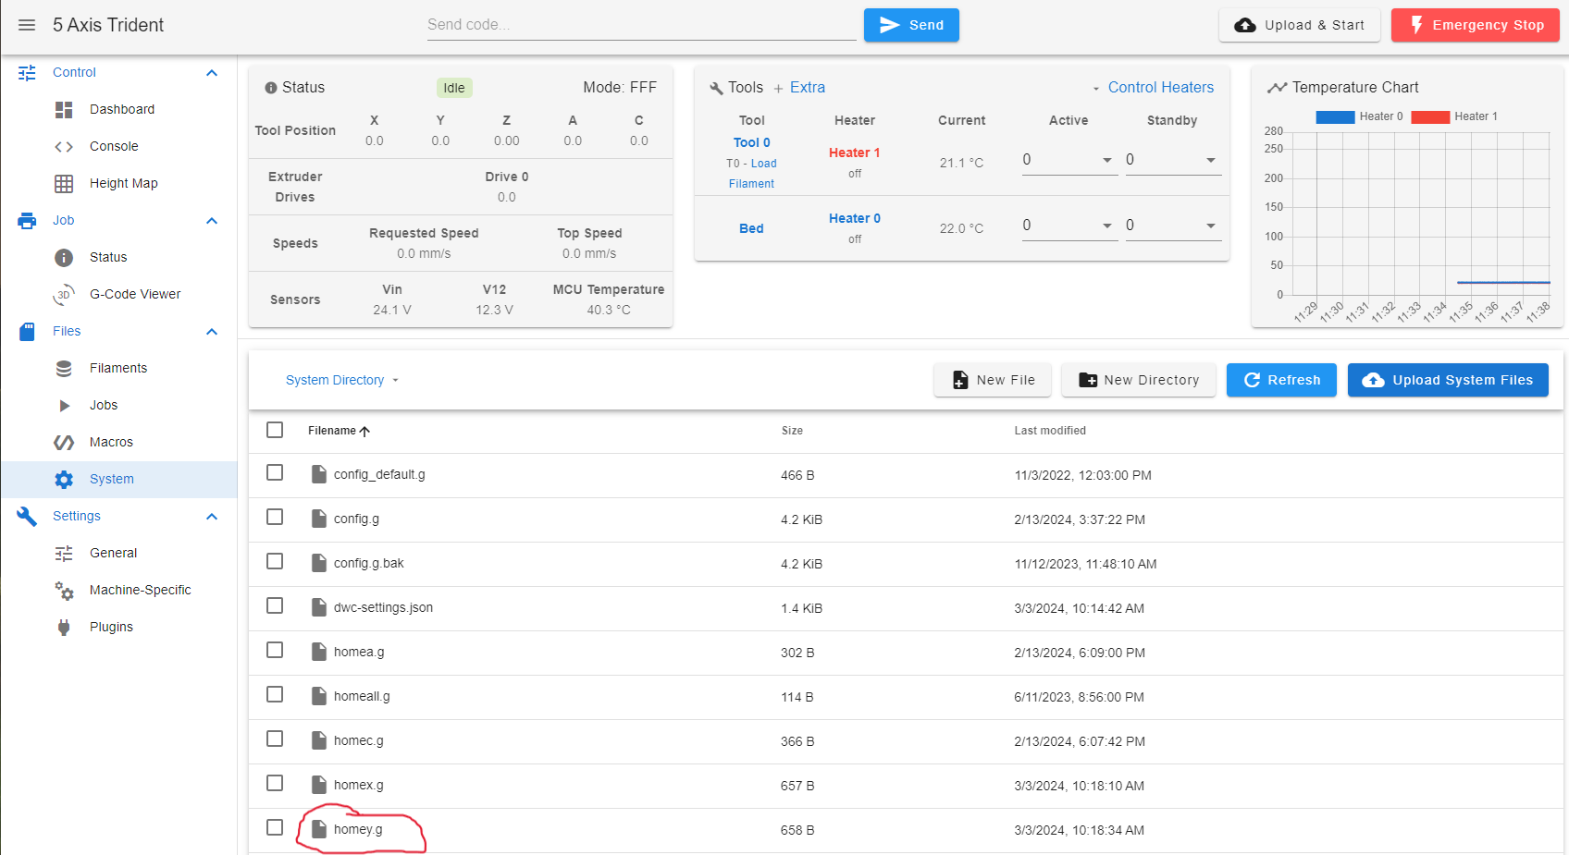

In the file, adjust the length of the Y axis in line 11 (in this example Y107.74 mm), after correction the value will be Y108.24 mm, exactly half of the measurement from our print where the distance was 1mm.

So in this case plus 0.5mm

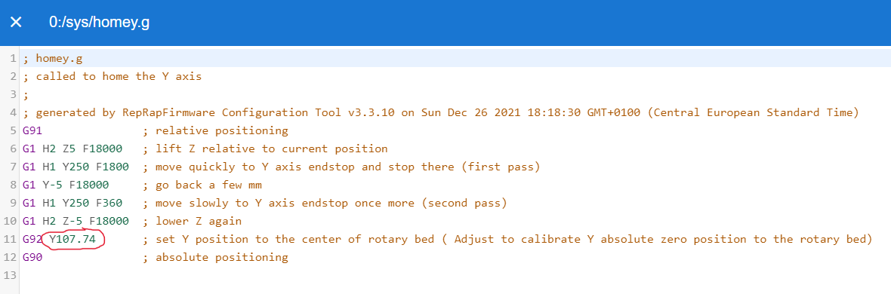

**Note:**

**If the second calibration strip Y C180 is printed a little more to the upper of the first calibration strip Y C0, the value will go to the plus.**

**If the calibration strip Y C180 is printed more down, from Y C0 the changed value will go to the minus.**

**The printer should now be calibrated for absolute zero on the C axis of the rotary bed.**